Diocesan Women’s
Winter Retreat
St. Crispin’s

February 25-27, 2022

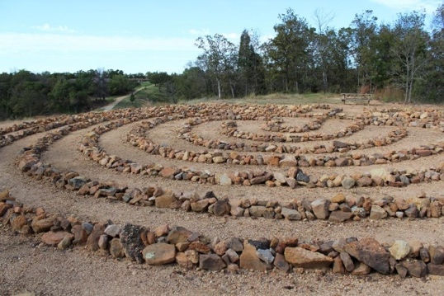

Who Do You Say That I Am?
Debbie Konieczny
Facilitator

Women across the diocese are invited to gather for fellowship, worship, inspiration, and recreation. Please join us for all or part of this retreat from 4 p.m. Friday through noon on Sunday.

We are planning on fellowship time around the fire pit in the evenings, and some structured interactive learning, and worship time. There will be outdoor and indoor activities.
Registration Form

Name:
Address:

Phone:

E-mail:

Special Needs:

Special Dietary Needs:

Housing:
Single $ 70 one night _________
$140 two nights _________
Double $ 50 one night _________
$100 two nights _________
I would like to room with:

______________________________

Meals:
Session 1: Friday dinner, Saturday breakfast, Saturday lunch.
Session 2. Saturday dinner, Sunday breakfast, Sunday lunch.

Session 1 $36.50 _________ Session 2 $36.50 _________

Housing/ Meals: TOTAL _________

Reservation Deadline:
February 14, 2022

Please complete this form and mail it with your check made out to ECW, Diocese of Oklahoma before February 14th to:

Fran Rahn
28200 S. Highway 125, Unit 14
Afton, OK 74331
530-559-1325
franrahn@gmail.com

For the safety of all, we ask that you be vaccinated and boosted. We will follow St. Crispin’s protocol of wearing masks indoors, except for meals, and providing space for social distancing. Please bring a copy of your CDC Covid-19 Vaccination Record Card.

This retreat is sponsored by the Episcopal Church Women of the Diocese of Oklahoma. Scholarships are available; contact Sherry Sullivan, 405-314-2083 ssullivan@coxinet.net

St. Crispin’s Conference Center
36302 Highway 9
Wewoka, OK 74884

